Project: 1B ML + Code Reasoning Model under 4GB VRAM

1. Problem Statement (Sharpened, Not Fluffy)
You wrote:
Base models struggle on complex tasks because they are trained on many topics.
That’s shallow.
The real problem is this:

Observed Failure Modes in 1B Models
Small (~1B) instruction models:
- Collapse under multi-step reasoning
- Produce shallow explanations for ML interview questions
- Hallucinate intermediate reasoning steps
- Lose structure under quantization (especially 4-bit)
- Fail to maintain logical dependency between steps
- Output syntactically invalid or incomplete code under constraints
Additionally:
- 4-bit quantization introduces representation compression noise
- This degrades attention precision and MLP activations
- Structured output quality drops first (not fluency — structure)

Precise Problem Statement
A 1B parameter base model lacks stable, structured multi-step reasoning capability for ML and code interview-style tasks, and this degradation worsens under 4-bit quantization due to precision loss in attention and MLP layers.
That is a real problem statement.

2. Hypothesis (Now Make It Testable)
You wrote:
Domain-specific LoRA fine-tuning will improve logical consistency.
Still too soft.
Let’s turn it into a measurable hypothesis.

Strong Hypothesis
Domain-specific QLoRA fine-tuning on structured ML + code reasoning data will improve step-level logical consistency and reduce hallucinated intermediate claims by at least 25% relative to the base model, while maintaining inference viability under 4-bit quantization within 4GB VRAM.
Now this is measurable:
- “25% improvement”
- “Step-level consistency”
- “Within 4GB VRAM”
If you can’t measure it, you’re doing vibes engineering.

3. Model Choice (Strategic, Not Emotional)
You chose TinyLlama 1.1B.
Good.

Why TinyLlama 1.1B?
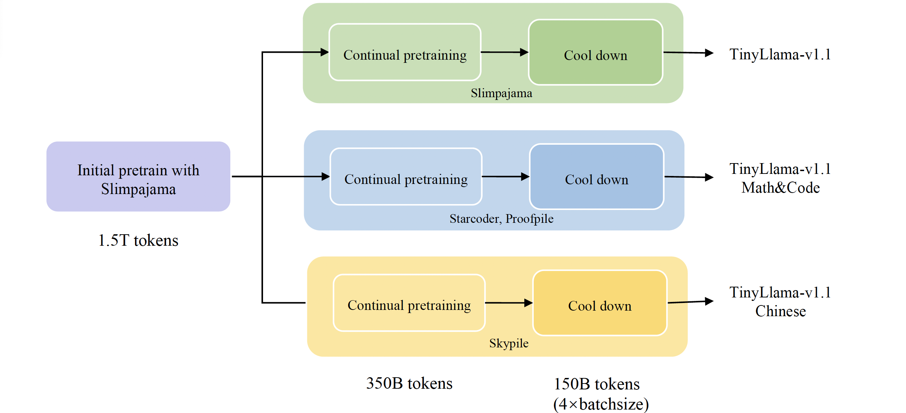
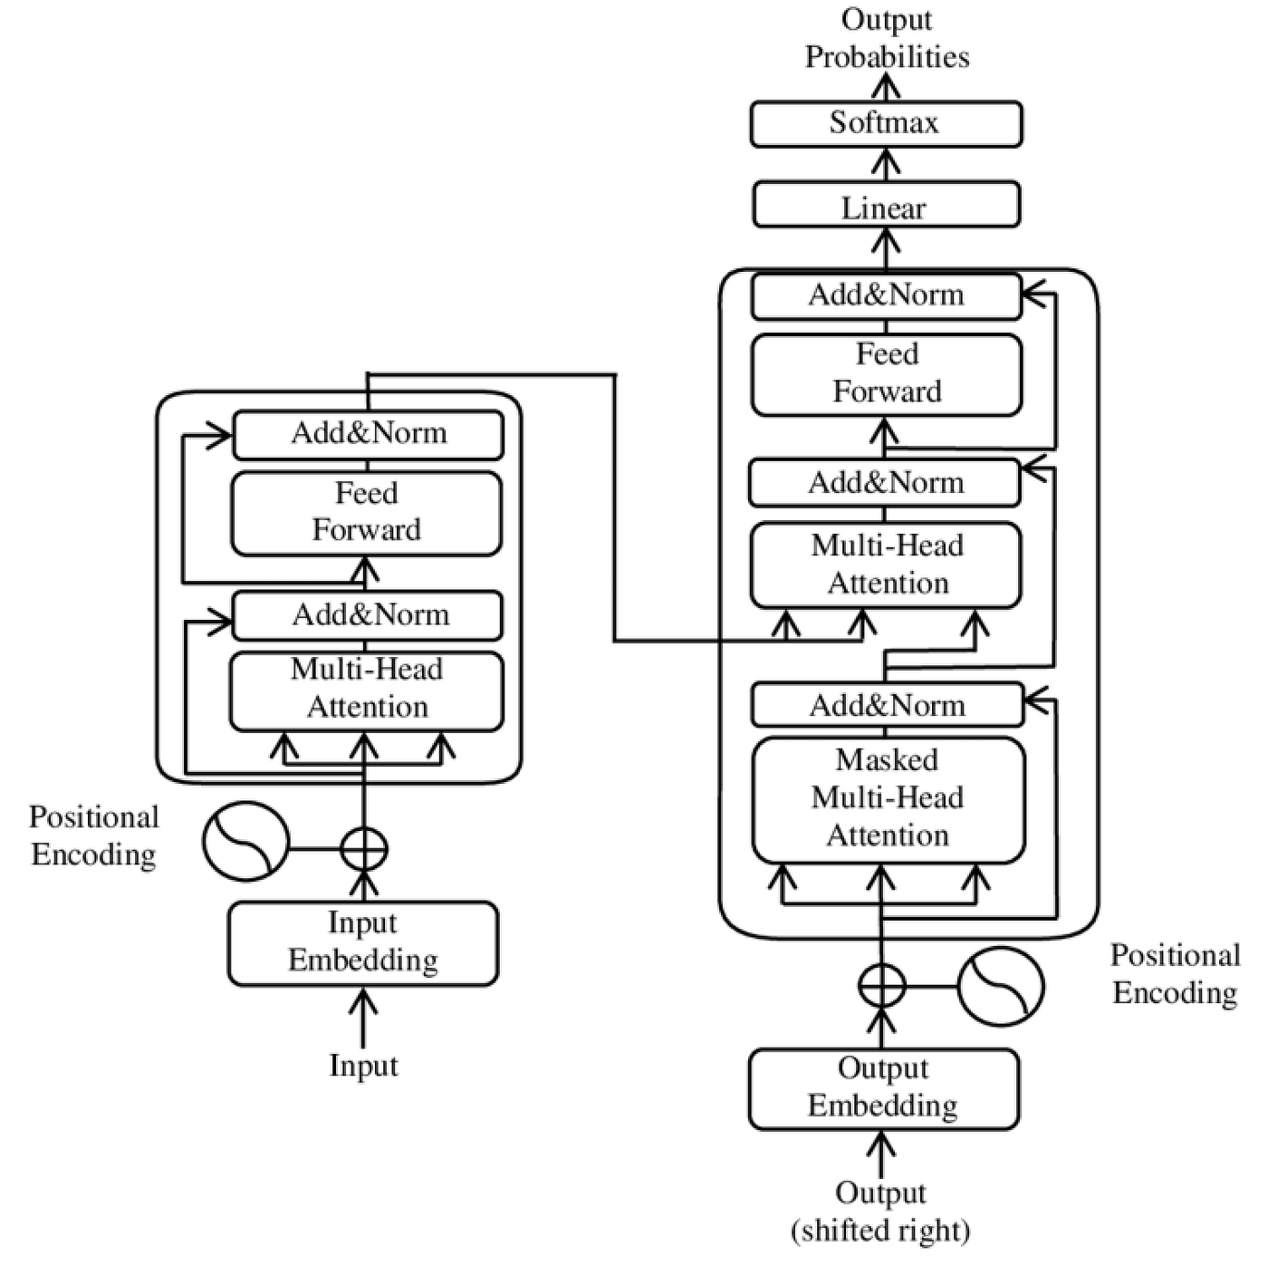

4
Model reference:
TinyLlama

Constraints You Actually Have
- RTX 3050 (4GB VRAM)
- Need 4-bit quantization
- Need gradient accumulation
- Need LoRA adapters only (no full fine-tune)

Configuration
- Base: TinyLlama 1.1B
- Quantization: 4-bit (NF4 via QLoRA)
- LoRA rank: 8 (start)
- Target modules:
  - q_proj
  - k_proj
  - v_proj
  - o_proj
  - gate_proj
  - up_proj
  - down_proj
You must adapt both attention and MLP.
If you only adapt attention, reasoning improves weakly.
MLP layers carry structured transformation logic.

4. Dataset Design (This Is Where You’re Weak)
You said:
Either synthetic or some form of data has to be taken from.
That’s not a design. That’s uncertainty.
You need structure.
Small models NEED scaffolding.

Required Format
### Question:
Why does Random Forest reduce overfitting compared to Decision Tree?
### Reasoning:
1. A single decision tree memorizes training noise.
2. Random Forest introduces bootstrapping.
3. Each tree sees different subsets of data.
4. Feature randomness reduces correlation.
5. Averaging predictions reduces variance.
6. Reduced variance lowers overfitting.
### Answer:
Random Forest reduces overfitting by reducing model variance through bootstrapping and feature randomness.
Key insight:
You are not training knowledge.
You are training reasoning structure discipline.

Dataset Sources (Be Strategic)
- Self-generated synthetic structured ML questions
- Interview-style explanations rewritten into structured format
- LeetCode-style reasoning rewritten into step format
- Your own ML notes converted to reasoning chains
Target:
- 5k–10k high-quality structured samples
- No garbage scraped data
- Clean step-numbered reasoning
If your data is noisy, your LoRA will amplify noise.

5. Evaluation Plan (Most Important Section)
Most people skip this. That’s why their projects are meaningless.
You need:

Metrics
- Step-level Logical Consistency
  - Does each step depend on previous?
- Hallucination Rate
  - % of reasoning steps unsupported by question
- Structural Integrity Score
  - Does model maintain Q → Reasoning → Answer format?
- Code Validity Rate
  - % syntactically correct outputs
- Latency
  - tokens/sec
- VRAM usage
- Perplexity (optional)

Experimental Grid
Model | Quant | LoRA | CoT | Result
Base | 4-bit | No | No | ?
Base | 4-bit | No | Yes | ?
Fine-tuned | 4-bit | Yes | Yes | ?
Fine-tuned | 8-bit | Yes | Yes | ?
If you don’t compare these — you learned nothing.

6. Failure Analysis Plan (This Is Where You Grow)
Define failure categories BEFORE training:
- Logical contradiction
- Missing reasoning step
- Incorrect final conclusion
- Repeated reasoning loops
- Code syntax error
- Early truncation
- Degenerate repetition under quantization
Track frequency of each.
Small models don’t fail randomly.
They fail systematically.
You must identify patterns.

Now I’ll Challenge You
Answer this in ONE sentence:
What exact capability should improve after fine-tuning?
If you say:
“Better reasoning.”
That’s weak.
The correct level is:
The model should produce logically ordered, variance-reducing, step-dependent reasoning chains for ML and code problems without introducing unsupported intermediate claims under 4-bit quantization.
If you can’t think this precisely, you’re not ready to train.

Now Let’s Level You Up (Technical Deep Dive)
Since you’re serious about tech:

QLoRA
QLoRA = Quantized Low-Rank Adaptation.
It:
- Freezes base model in 4-bit
- Trains low-rank adapters in higher precision
- Backpropagates through quantized weights using double quantization
Key concept: NF4 (NormalFloat4)
NF4 is not uniform 4-bit.
It is distribution-aware quantization optimized for normally distributed weights.
Curiosity triggers:
- Why does quantization hurt attention layers more than embeddings?
- What happens if LoRA rank increases beyond intrinsic rank of task?
- Why does low-rank adaptation work at all? What does that imply about transformer overparameterization?
- What would happen if you LoRA only MLP and not attention?
- Why does structured reasoning collapse earlier than fluency under precision loss?
Think about these.

Strategic Advice
Right now your biggest risk isn’t GPU.
It’s vagueness.
If you rush into training without:
- clean dataset
- evaluation harness
- failure logging
You’ll waste weeks.
This project can either be:
Resume decoration.
Or
A publishable-style technical case study on SLM reasoning under quantization.
Decide which one you’re building.
Now answer:
In one sentence — what exact measurable improvement are you targeting?
can u egenrate a doc base on exact steps and all
Good. Now we stop talking and formalize this like engineers — not hobbyists.
Below is a complete 1–2 page research-grade design document you could literally commit as design_doc_v1.md.
No fluff. No vagueness. No resume decoration energy.

Design Document
Project: Structured ML + Code Reasoning Fine-Tuning for 1B Model Under 4GB VRAM
Author: Sarthak Mohapatra
Hardware Constraint: RTX 3050 (4GB VRAM)

1. Problem Statement

1.1 Background
Small language models (~1B parameters) demonstrate degraded multi-step reasoning capability compared to larger models. This degradation becomes more severe under aggressive quantization (4-bit), which is required to fit models into 4GB VRAM.
Empirically observed weaknesses in 1B models:
- Collapse in structured multi-step reasoning
- Logical inconsistencies between reasoning steps
- Hallucinated intermediate claims
- Loss of output structure under quantization
- Reduced code correctness under constrained generation
- Early termination or repetitive loops in longer outputs
Quantization (especially 4-bit) introduces precision loss in attention and MLP activations, disproportionately affecting structured reasoning before surface-level fluency degrades.

1.2 Core Problem
A 1B parameter base instruction model lacks stable, structured, multi-step reasoning capability for ML and code interview-style tasks, and this instability worsens under 4-bit quantization due to precision degradation in transformer layers.

2. Hypothesis
Domain-specific QLoRA fine-tuning on explicitly structured ML and code reasoning data will improve step-level logical consistency and reduce hallucinated intermediate reasoning steps by ≥25% relative to the base 4-bit model, while remaining within 4GB VRAM constraints.
Secondary hypothesis:
Structured supervision (Question → Step-by-step Reasoning → Answer) will improve structural integrity and reduce early termination under quantization.

3. Model Configuration

3.1 Base Model
Model: TinyLlama 1.1B
Reasoning:
- Fits within 4GB VRAM under 4-bit
- Stable open-weight base
- Supports QLoRA + gradient accumulation
- Architecture similar to LLaMA-style transformer

3.2 Training Method
Method: QLoRA (Quantized Low-Rank Adaptation)

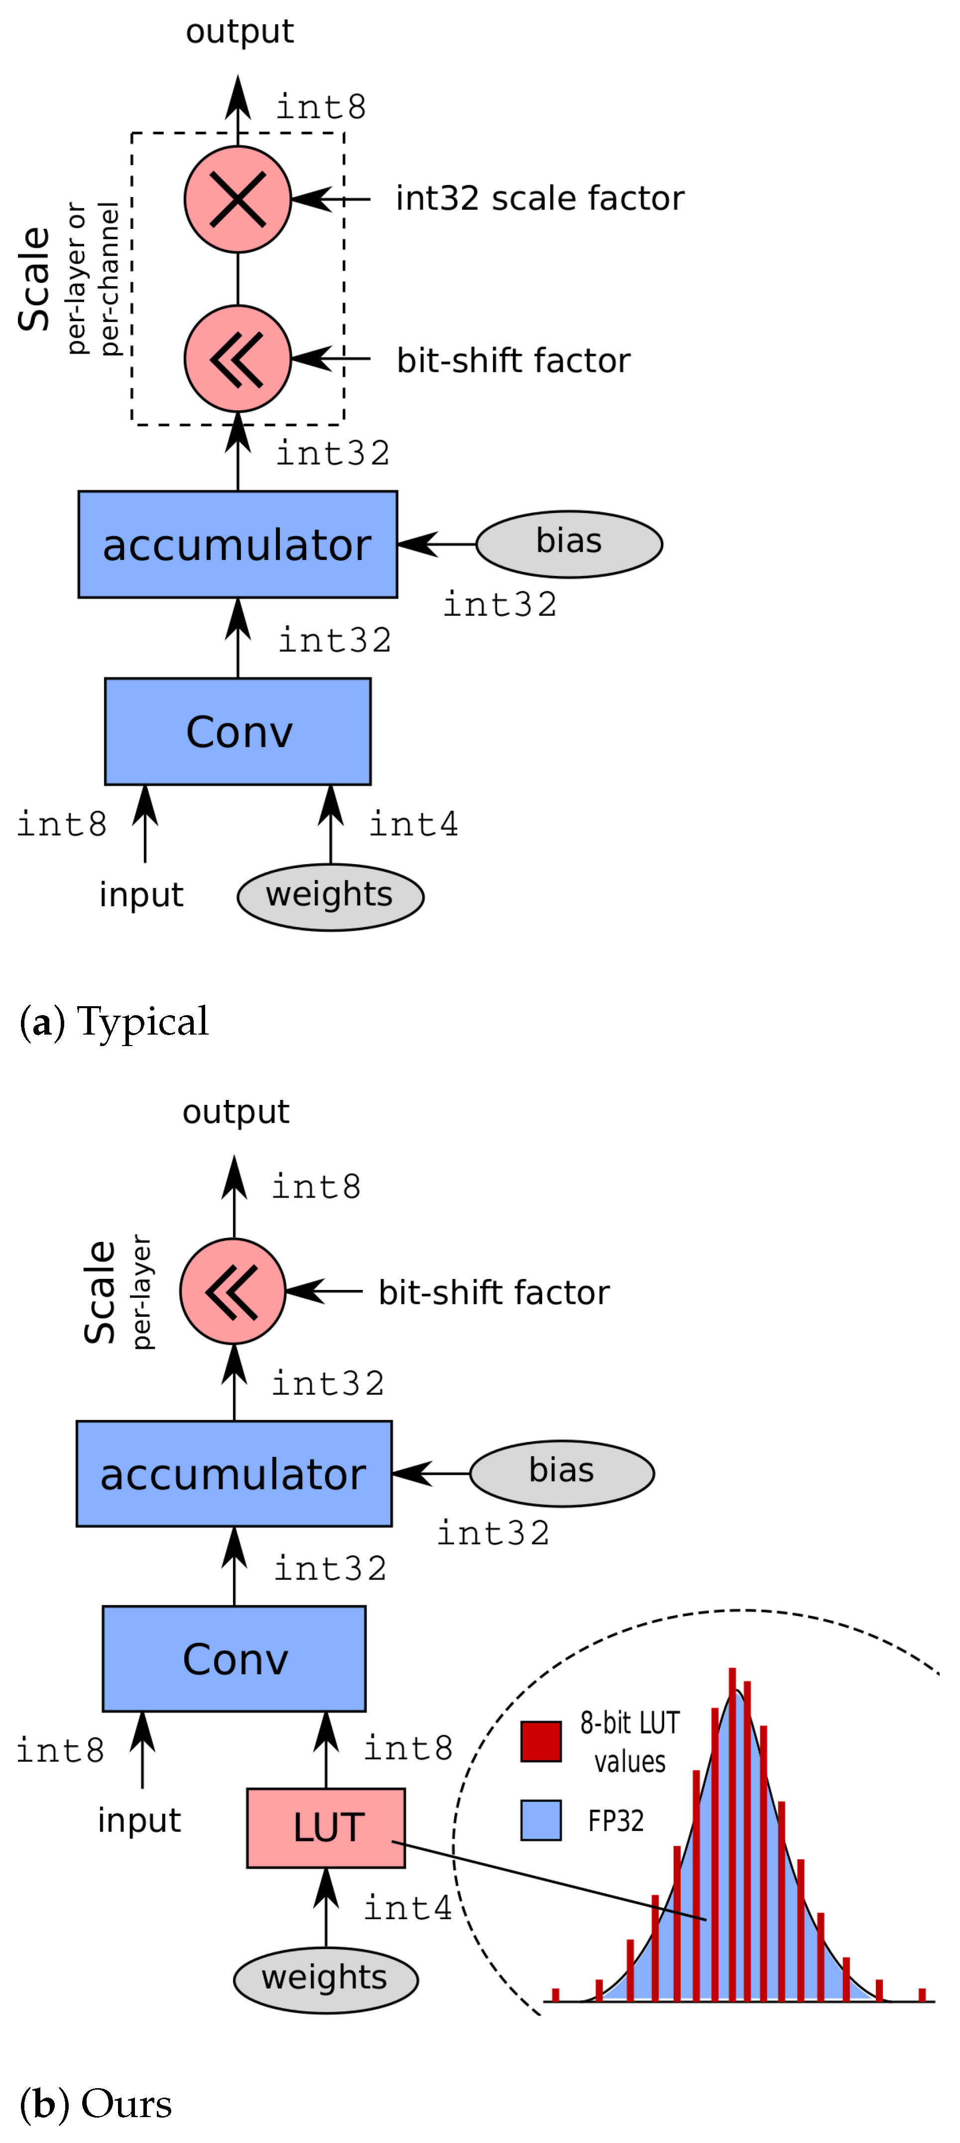
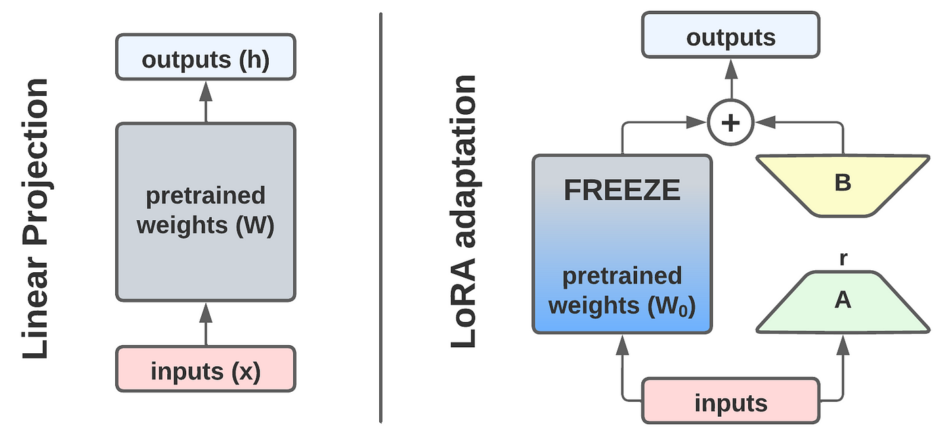
4

Configuration:
- Quantization: 4-bit (NF4)
- Compute dtype: bfloat16
- LoRA rank: 8 (initial)
- LoRA alpha: 16
- Dropout: 0.05

Target Modules:
- q_proj
- k_proj
- v_proj
- o_proj
- gate_proj
- up_proj
- down_proj
Both attention and MLP layers are adapted to preserve reasoning transformation capacity.

4. Dataset Design

4.1 Objective
Train structured reasoning discipline — not just knowledge recall.
Small models require scaffolding.

4.2 Sample Format (Strict Template)
Each training sample:
### Question:
Why does Random Forest reduce overfitting compared to Decision Tree?
### Reasoning:
1. A single decision tree has high variance.
2. High variance leads to overfitting.
3. Random Forest uses bootstrapping.
4. Each tree sees different training samples.
5. Feature randomness reduces tree correlation.
6. Averaging predictions reduces variance.
7. Reduced variance lowers overfitting.
### Answer:
Random Forest reduces overfitting by lowering variance through bootstrapping and feature randomness.
Rules:
- Minimum 4 reasoning steps
- Numbered steps only
- Each step must logically depend on previous
- Final answer must summarize reasoning concisely

4.3 Data Sources
Target size: 5,000–10,000 samples
Sources:
- Synthetic ML reasoning questions (self-generated)
- Interview-style ML questions rewritten structurally
- Code reasoning tasks (bug explanation, complexity reasoning)
- DSA explanation problems
- Your own ML notes converted into step format
No raw scraped internet dumps.
Quality > quantity.

5. Training Plan

Week 1
- Write final dataset schema
- Build dataset validation script
- Implement evaluation harness
- Prepare base benchmark results

Week 2
- Run QLoRA fine-tuning (3–5 epochs)
- Monitor loss + validation perplexity
- Save checkpoints

Week 3
- Evaluate:
  - Base 4-bit
  - Fine-tuned 4-bit
  - Fine-tuned 8-bit
- Run structured reasoning test suite

Week 4
- Failure analysis
- Ablation:
  - Attention-only LoRA
  - MLP-only LoRA
- Write technical breakdown

6. Evaluation Plan
This project fails without rigorous evaluation.

6.1 Metrics

1. Structured Accuracy
% outputs maintaining required format

2. Step-Level Logical Consistency
Manual + rule-based scoring:
- No contradiction between steps
- Each step references prior logic

3. Hallucination Rate
% reasoning steps unsupported by question

4. Code Validity Rate
% syntactically valid outputs (AST parse check)

5. Latency
Tokens/sec

6. VRAM Usage
Peak usage during inference

6.2 Experimental Matrix
Model | Quant | LoRA | CoT | Structured Score
Base | 4-bit | No | Yes | ?
Base | 8-bit | No | Yes | ?
Fine-tuned | 4-bit | Yes | Yes | ?
Fine-tuned | 8-bit | Yes | Yes | ?

7. Failure Analysis Plan
Failures categorized into:
- Logical contradiction
- Missing reasoning step
- Unsupported intermediate claim
- Repetitive loop
- Early truncation
- Code syntax error
- Structure collapse
Each output will be labeled by failure type.
Goal is not just to improve — but to understand how small models break under compression.

8. Success Criteria
Project is successful if:
- ≥25% improvement in logical consistency score
- ≥20% reduction in hallucinated reasoning steps
- ≥15% improvement in structured output stability
- Model remains deployable under 4GB VRAM

9. Exact Capability Improvement (One Sentence)
The fine-tuned model should reliably produce logically ordered, step-dependent reasoning chains for ML and code problems without introducing unsupported intermediate claims, even under 4-bit quantization.
That is your north star.

